News Research Tool

The domain of the Project:

Python

Team Mentors (and their designation):

Mr.Gaurav Patel

Team Members:
Ms.Tanvi Vikram Choure

Period of the project

June 2025 to May 2026

Declaration
The project titled “News Search Tool” has been mentored by Gaurav Patel, organised by SURE Trust, from April 2023 to August 2023, for the benefit of the educated unemployed rural youth for gaining hands-on experience in working on industry relevant projects that would take them closer to the prospective employer. I declare that to the best of my knowledge the members of the team mentioned below, have worked on it successfully and enhanced their practical knowledge in the domain.

Team Members:
Ms. Tanvi Vikram Choure

Mr. Gaurav Patel
Data Engineer at Celebal Technologies

Prof. Radhakumari
Executive Director & Founder
SURE Trust

Table of contents
- Executive summary
- Introduction
- Project Objectives
- Methodology & Results
- Social / Industry relevance of the project
- Learning & Reflection
- Future Scope & Conclusion

Executive Summary
In this project, the implementation of the Retrieval-Augmented Generation (RAG) based Question Answering model is done. This model is based on the idea of semantic search along with the use of large language models. This model is useful for the processing of unstructured documents by the use of dense vector representations. The use of the Sentence Transformers library is made for the generation of these vector representations. These representations are then efficiently searched by the use of the FAISS library. The backend is developed by the use of the FastAPI framework, and the deployment is done in an efficient manner by the use of Ray Serve. The experimental results show the efficiency of the model by the reduced hallucination, accuracy, and response time.

Important Aspects:
•Developed a Retrieval-Augmented Generation (RAG) based Question Answering system.
•Enables accurate, context-aware responses from large documentation.
•Uses vector search (FAISS) for fast and efficient information retrieval.
•Reduces LLM hallucination by grounding answers in real data.

Introduction
In the current digital age, organizations are creating large amounts of documentation, making it hard to search and retrieve relevant information efficiently. Current search systems based on keywords may not effectively comprehend the semantic meaning of the query entered by the user. Additionally, relying directly on Large Language Models (LLMs) may not always give accurate information.

To resolve this issue effectively, this project proposes the implementation of a Retrieval-Augmented Generation (RAG) based Question Answering system. The proposed solution uses vector similarity search along with an LLM to produce accurate information. The documentation is first converted into vectors and stored in a FAISS index. Once the user queries the system with a question, the system retrieves the most relevant information from the documents and provides them as context to the LLM.

The proposed solution is modular, scalable, and production-ready, making it suitable for real-world applications such as knowledge management systems, research assistants, and intelligent search systems for documents.

Project Objectives
Project Objectives and Goals:
- Design and develop a Retrieval-Augmented Generation (RAG) based Question Answering system.
- Facilitate accurate information retrieval from large documentation.
- Eliminate the issue of hallucination from LLM responses by referencing real data.
- Implement an efficient vector similarity search.
- Design a scalable backend API service with FastAPI and Ray Serve.
- Create a modular architecture to ease future modifications without model retraining.

Expected Outcomes and Deliverables:
- A complete document-based question answering web application.
- Vectorized document database.
- Fast and accurate similarity search system.
- Context-grounded answer generation with LLM.
- Deployment-ready backend API service.
- Documentation of the project architecture, workflow, and technical details.
- Demonstration of the effectiveness of the solution in eliminating hallucination from LLM responses.

Methodology and Results
Methods / Technology Used:
The architecture is based on a Retrieval Augmented Generation (RAG) model, which combines information retrieval and generative language modeling. The documents are first encoded into dense vector space, which stores semantic information, using a Sentence Transformer model. These vectors are stored in a FAISS vector index, which allows for efficient information retrieval based on vector distances.
When a user enters a query, it is encoded into a vector space and compared with the stored document vectors. The top relevant document chunks are combined with the original query, and a structured prompt engineering technique is applied. The structured prompt is then passed into a Large Language Model (LLM), which generates a response that is grounded and context-aware. The entire architecture is based on a REST API, which provides a scalable and efficient way for backend communication.

Tool/Software Used:
Languages: Python
Frameworks: Langchain, OpenAI / LLM, Sentence Transformer,FastAPI
Development Tools: VScode,Gi
Project Repository:

Project Architecture:
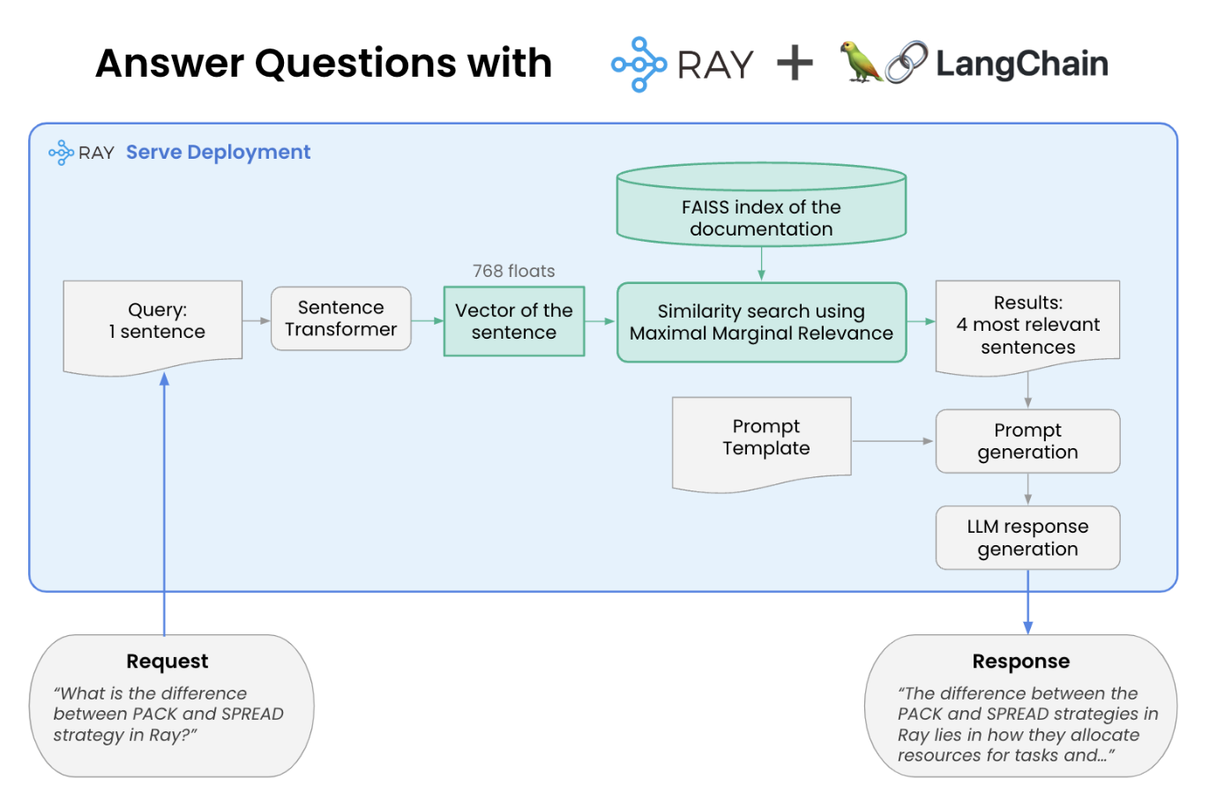

Learning and Reflection
The development of the AI-based Website Question Answering System offered substantial technical, analytical, and real-world learning experiences in a variety of fields, especially Artificial Intelligence, Natural Language Processing, and system deployment.
Technical Learnings:
In terms of technical learning, this project helped to gain a deeper understanding of Large Language Models, especially the use of Retrieval Augmented Generation and Vector Semantic Search. Working with LangChain helped to gain a deeper understanding of how to build a variety of AI-related pipelines, such as document loading, splitting, and generation, and retrieval models. In terms of using Vector Databases, especially using FAISS, this project helped to gain a deeper understanding of how to use similarity search and information retrieval. Understanding how Sentence Vector Embeddings transform sentences into vectors helped to gain a deeper understanding of semantic representation and contextual similarity. This project also helped to gain a deeper understanding of how to use Prompts, especially to reduce hallucinations, and using OpenAI and OpenRouter API integration.
Further, this project helped to gain a deeper understanding of API integration, especially using OpenAI and OpenRouter, and how to reduce hallucinations.
Analytical & Problem-Solving Learnings:
Some of the real-world problems that were encountered during the development of the model include:
- Handling unstructured content of websites
- Handling API rate limits and quota restrictions
- Handling irrelevant or hallucinated responses
- Handling the optimization of chunk size and overlap for better accuracy in information retrieval
- Handling the optimization of performance and response latency
These problems have helped in improving analytical, problem-solving, and debugging capabilities.
System Design & Deployment Experience:
This project has given valuable experience in designing a RAG architecture that is highly scalable, including:
- Document Ingestion Pipeline
- Text Chunking Strategy
- Embedding Generation
- Vector Indexing

Conclusion and Future Scope
Objective:
- To develop an AI-powered system capable of extracting information from any website and providing accurate answers to user queries.
- To implement a Retrieval-Augmented Generation (RAG) architecture to reduce hallucinations and improve answer reliability.
- To convert unstructured website content into vector embeddings for semantic search and contextual retrieval.
- To integrate Large Language Models (LLMs) for generating precise, context-aware responses.
- To design a user-friendly interface for easy interaction with the system.
- To build a scalable and modular architecture suitable for real-world deployment.

Future Scope of the Project
The project has strong potential for further enhancement and real-world scalability. Future improvements may include:
- Integration of multiple website URLs simultaneously for broader knowledge access.
- Addition of PDF and document upload support for enterprise knowledge systems.
- Implementation of chatbot-style conversational memory for multi-turn dialogue.
- Deployment on cloud platforms for large-scale enterprise use.
- Integration of advanced vector databases like Pinecone or Weaviate for improved scalability.
- Implementation of role-based access control for secure enterprise environments.
- Addition of multilingual support for global usability.
- Optimization for faster retrieval and lower latency in high-traffic scenarios.

Conclusion:
The proposed AI-based Website Question Answering System using the concept of Retrieval Augmented Generation of Large Language Models was successfully implemented, thereby validating the effectiveness of the proposed concept of using vector search in the field of AI. The proposed AI-based Website Question Answering System successfully fills the void between unstructured data available over the internet and the application of intelligent information systems, thereby answering queries posed by users in an efficient and accurate manner.The proposed AI-based Website Question Answering System, through the application of advanced AI concepts, design, and processing, is a reflection of the current industry standards in the field of Artificial Intelligence.

